The University of Azad Jammu and Kashmir, Muzaffarabad

Name :Alishba Zakir
Roll No: 2024-SE-02
Course: Computer Networks
Course Code: SE-2203
Lab# 2
Submitted To: Engr. Dr. Asma Javaid
Submitted By: Alishba Zakir
Date : 4 Mar, 2026

Department Of Software Engineering
Task: Create and Test a Simple LAN in Cisco Packet Tracer

- Part A: Network Topology Creation :

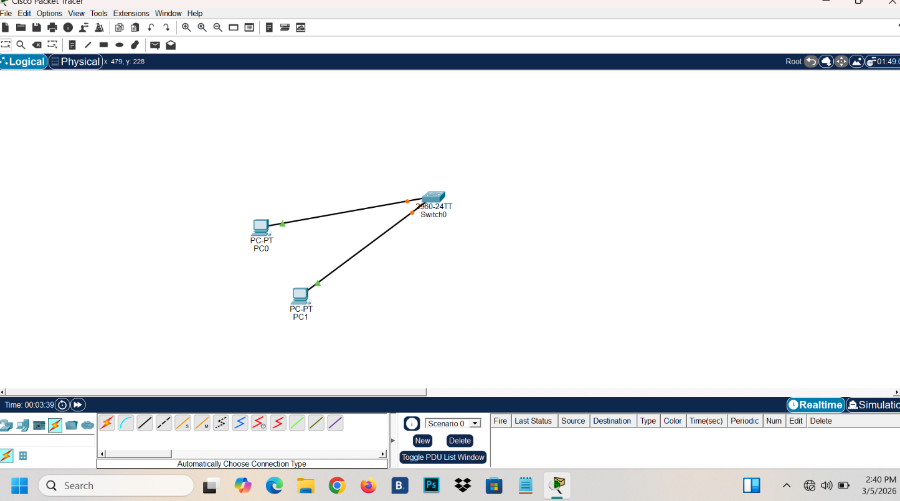

This is a basic network topology created in Cisco Packet Tracer. Two PCs are connected to a switch using straight-through Ethernet cables, demonstrating simple LAN connectivity for beginners learning networking concepts.

- Part B: IP Adress Configuration:

- IP Adress for PC0:

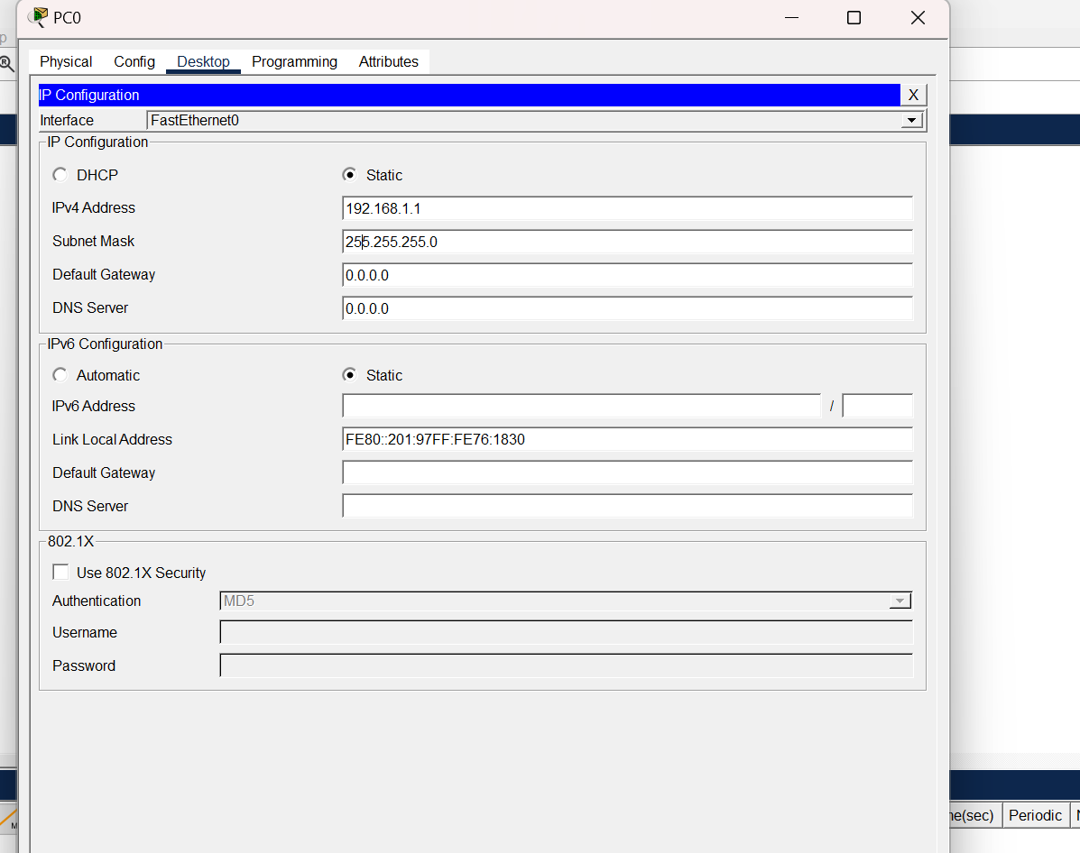

2.IP Adress for PC1:

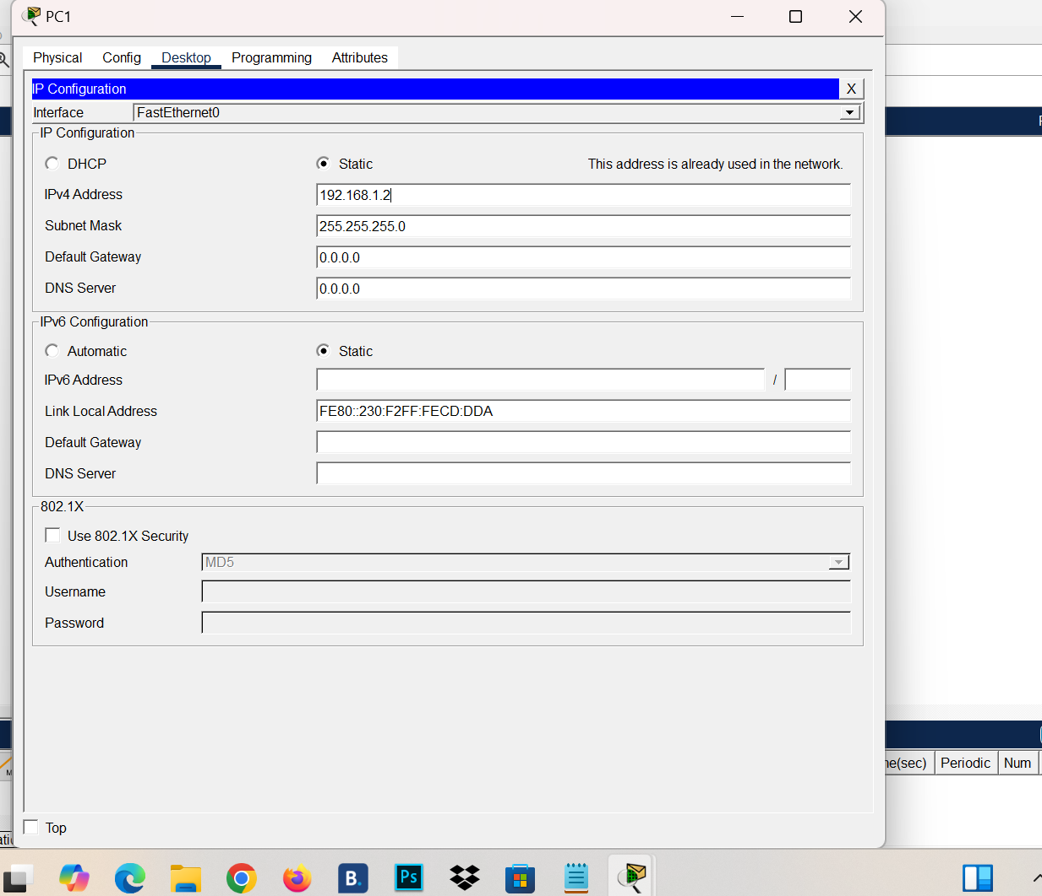
IP Address Configuration Note
- PC0
  - IP Address: 192.168.1.1
  - Subnet Mask: 255.255.255.0
- PC1
  - IP Address: 192.168.1.2
  - Subnet Mask: 255.255.255.0
Summary:
Both PCs are configured in the same subnet (192.168.1.0/24). This allows them to communicate directly with each other without requiring a router, as long as they are connected to the same switch or hub.

- Part 3: Network Testing Using CLI Command:

1: ipconfig
A command-line utility in Windows used to display and manage network configuration details. It helps troubleshoot network connectivity issues.
Uses
- Diagnose network issues (e.g., no internet, IP conflicts).
- Reset or refresh IP addresses.
- Clear DNS cache to resolve domain name errors.
- Verify network adapter setting

2: ping:
A command-line utility used to test connectivity between your computer and another device (host) on a network. It sends small packets of data (ICMP Echo Requests) and waits for replies (ICMP Echo Replies).
- For PC0:

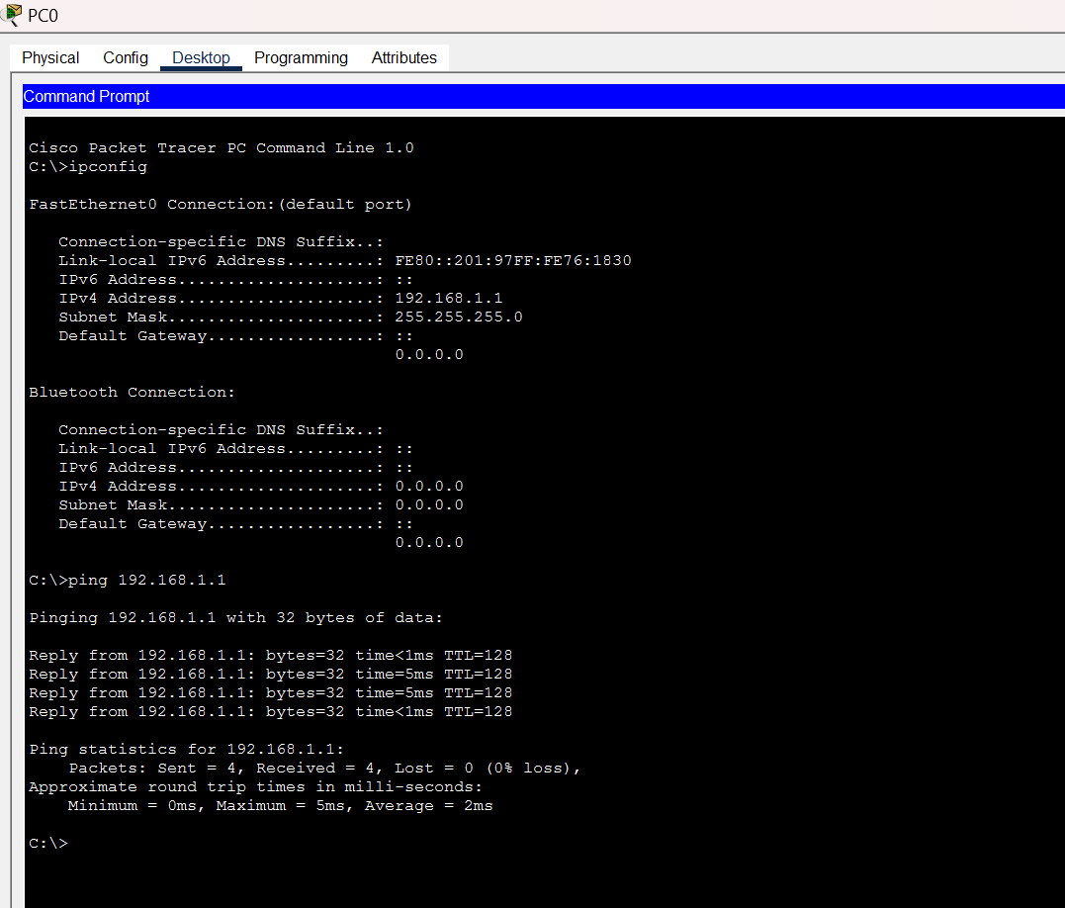

- For PC1:

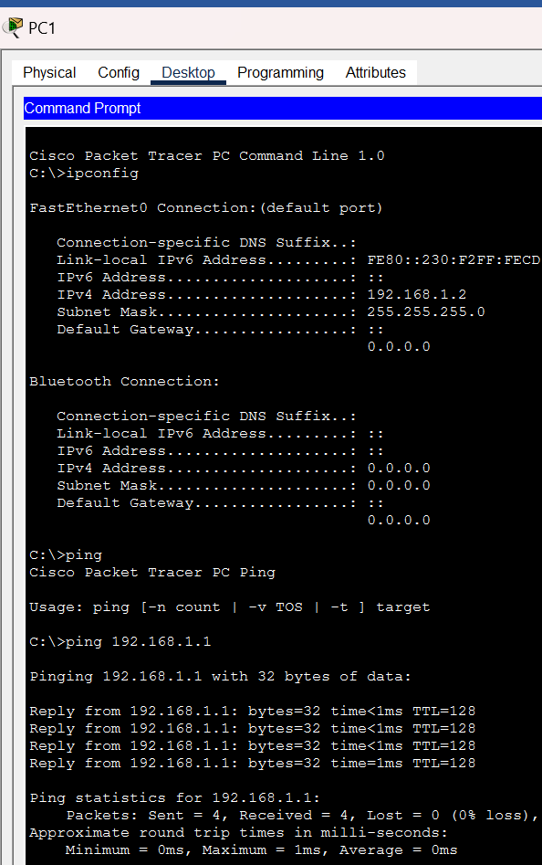

3: tracert:
Tracert command shows the path that data packets take from your computer to the destination IP address. It also display each hop and time taken to reach it .
- For PC0:
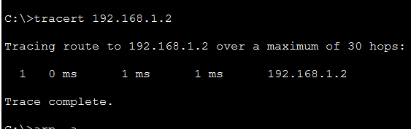

- For PC1:

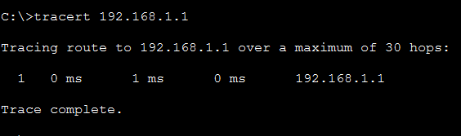

4: arp -a:
The arp -a command is used in Windows (and similarly in some Unix/Linux systems) to display the Address Resolution Protocol (ARP) table. This table shows the mapping between IP addresses and their corresponding MAC (hardware) addresses that your computer has recently communicated with on the local network.

5: netstat:
Netstat command shows active network connection on the computer .lt also displays information about ports ,protocols ,network statistics.

- For PC0:
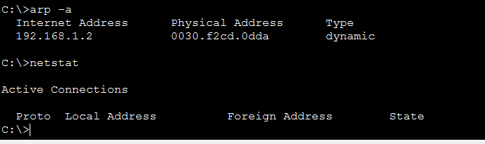
- For PC1:

